COMPUTER NETWORKS
Week 1 – Complete Study Notes
Based on: Computer Networks, 6th Edition – Tanenbaum & Wetherall
Instructor: Dr. Mohammad Shahidul Islam

Topic 1: What is a Computer Network?

Definition
A computer network connects two or more autonomous computers so they can communicate and share resources.

⭐ Important:
Key word: Autonomous = Each computer works independently. It does NOT need the other computer to function.

Simple Real-Life Example
Imagine your home. You have a laptop, a mobile phone, and a printer. When you connect them using Wi-Fi, they form a small computer network.
- Your phone can print a document using the shared printer.
- Your laptop can access files from the phone.
- All devices can share one internet connection.

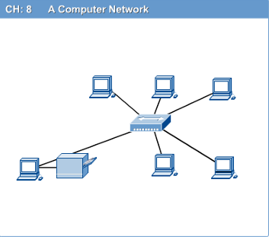

🧠 Memory Trick:
NETWORK = Devices + Cables/Wireless + Sharing. Think of it like a group of friends sharing notes!

🇧🇩 Bangla Summary:
কম্পিউটার নেটওয়ার্ক হলো দুই বা তার বেশি কম্পিউটারের সংযোগ, যেখানে তারা তথ্য এবং রিসোর্স শেয়ার করতে পারে। প্রতিটি কম্পিউটার স্বাধীনভাবে কাজ করতে পারে।

Topic 2: Types of Networks – LAN, MAN & WAN
Networks are classified by their geographical size. Think of it like: small area → big area.

LAN – Local Area Network
- Covers a small area like a room, building, or campus.
- Example: The computer lab in your university is a LAN.
- Speed is very high (usually 100 Mbps to 10 Gbps).
- Owned and managed by one organization.

MAN – Metropolitan Area Network
- Covers a city or town.
- Example: A cable TV network across Dhaka city is a MAN.
- Larger than LAN but smaller than WAN.
- Sometimes connects multiple LANs within a city.

WAN – Wide Area Network
- Covers a country or even the entire world.
- Example: The Internet is the biggest WAN in the world.
- Speed is lower than LAN because data travels long distances.
- Uses telephone lines, satellites, and fiber optic cables.

Network Type | Coverage Area / Example
LAN (Local Area Network) | Room, Building, Campus → e.g., University computer lab
MAN (Metropolitan Area Network) | City → e.g., Dhaka city cable TV network
WAN (Wide Area Network) | Country / World → e.g., The Internet

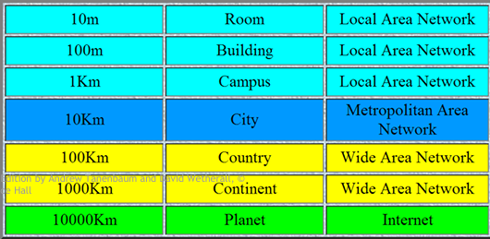

🧠 Memory Trick:
L = Local (small), M = Metro/City (medium), W = Wide (very large). Remember: L → M → W = Small → Medium → Large!

🇧🇩 Bangla Summary:
LAN হলো ছোট এলাকার নেটওয়ার্ক (যেমন: বিশ্ববিদ্যালয়ের ল্যাব)। MAN হলো শহরের নেটওয়ার্ক। WAN হলো দেশ বা পৃথিবীজুড়ে বিস্তৃত নেটওয়ার্ক (যেমন: ইন্টারনেট)।

Topic 3: Applications of Networks
Why do we use computer networks? Networks make life easier in many ways:

1. Resource Sharing
- Hardware sharing: Many computers share one printer or one hard disk.
- Software sharing: Many users use one application installed on a server.
Real-life example: In an office, 20 employees share one network printer. Nobody needs their own printer!

2. Information Sharing
- Files and databases can be accessed from anywhere.
- Google Search is a good example – you search for information from any location.
Real-life example: A hospital database where doctors from different floors access the same patient records.

3. Communication
- Email: Send messages to anyone in the world instantly.
- Message broadcast: Send one message to many people at once.
- Remote computing: Use a computer that is physically far away.
Real-life example: You send an email from Bangladesh to someone in USA. It reaches in seconds.

4. Distributed Processing (GRID Computing)
- A big task is divided among many computers.
- Each computer solves a small part of the problem.
Real-life example: Scientists use thousands of computers across the world to analyze weather patterns.

Network Applications We Use Daily
- E-mail
- Web Sites (WWW – World Wide Web)
- E-Commerce (Online shopping – Daraz, Amazon)
- Internet Telephony (VoIP – WhatsApp calls, Zoom)
- Video Conferencing
- Instant Messengers (WhatsApp, Messenger)
- Internet Radio and Streaming

🧠 Memory Trick:
Networks = Sharing + Communication + Information Access. Think: SHARE, TALK, FIND.

🇧🇩 Bangla Summary:
নেটওয়ার্কের মাধ্যমে আমরা রিসোর্স শেয়ার করি (প্রিন্টার, সফটওয়্যার), তথ্য শেয়ার করি (ইমেইল, ওয়েবসাইট), এবং যোগাযোগ করি (VoIP, ভিডিও কল)। ইন্টারনেটও একটি বিশাল নেটওয়ার্ক।

Topic 4: Network Topology (BSRM)
Topology means the layout or shape of the network. How are the computers and cables arranged?
⭐ Important:
Memory trick for 4 topologies: B-S-R-M = Bus, Star, Ring, Mesh

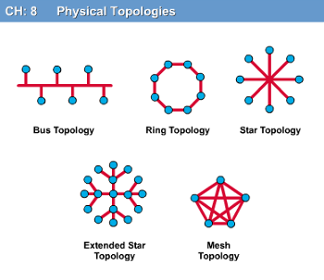

1. Bus Topology
All devices are connected to ONE single cable called the 'bus' or 'backbone'.
- Data travels along the cable in both directions.
- Simple and cheap to set up.
- Problem: If the main cable breaks, the entire network fails.
- Used in older Ethernet networks.
Real-life example: Like a street with houses on both sides — the road is the bus cable!

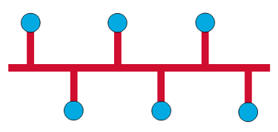

2. Star Topology
All devices are connected to a central device called a Hub or Switch.
- Most popular topology used today in homes and offices.
- If one cable fails, only that one device is affected.
- If the central hub/switch fails, the entire network fails.
- Looks like the spokes of a bicycle wheel.
Real-life example: Your home Wi-Fi router is the center. Your phone, laptop, and TV all connect to it.

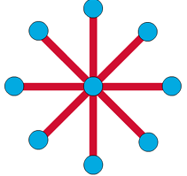
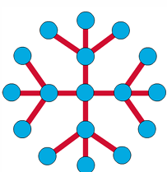
Extended Star / Tree Topology
- Larger networks use multiple stars connected together.
- Also called Tree Topology.
- Uses routers, switches, and bridges to filter traffic.
- More efficient – sends data only to the correct destination.

3. Ring Topology
All devices are connected in a circle. Data travels around the ring from one device to the next.
- A frame (small packet of data) travels around the ring.
- Each device checks if the data is for it. If yes, it takes it.
- Single Ring: Data flows in one direction only.
- Dual Ring: Data flows in both directions. More reliable.
Real-life example: Imagine children sitting in a circle passing a note. Each child reads the name on the note. If it is for them, they keep it. Otherwise, they pass it on.

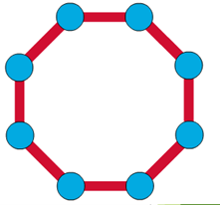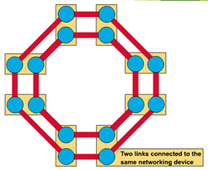

4. Mesh Topology
Every device is connected to every other device. Multiple paths exist between devices.
- Very reliable – if one path fails, data takes another path.
- Used in WANs and mission-critical networks (banks, military).
- Very expensive to install because of many cables.
- Provides fault tolerance (network still works even if some links fail).
Real-life example: Highways between major cities — if one road is blocked, you take another route!

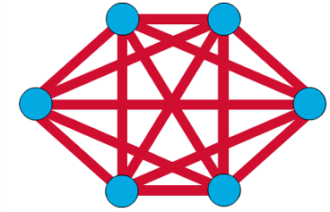

Topology | Key Feature / Weakness
Bus | One cable for all. Cheap but single point of failure.
Star | Central hub. Easy to manage but hub failure = network down.
Ring | Circle connection. Data passes node to node.
Mesh | Every device connected. Most reliable but most expensive.

🧠 Memory Trick:
BSRM = Bus (1 cable), Star (center hub), Ring (circle), Mesh (all connected). Remember: 'Be Smart, Ring Mesh!'

🇧🇩 Bangla Summary:
নেটওয়ার্ক টপোলজি হলো নেটওয়ার্কের গঠন বা বিন্যাস। চারটি প্রধান টপোলজি: Bus (একটি তার), Star (কেন্দ্রে হাব), Ring (বৃত্তাকার), Mesh (সব ডিভাইস একে অপরের সাথে সংযুক্ত)।

Topic 5: Network Components (PINCONA)
A network needs several parts to work. Remember the word: P-I-N-C-O-N-A
⭐ Important:
PINCONA = Physical media, Interconnecting devices, Networks software, Computers, Operating system, Networking Applications

1. Physical Media (Networking Media)
The medium through which data is sent from one device to another.
- Wired: Twisted pair cables (LAN), Coaxial cable (Cable TV), Fiber optic (long distance, fast)
- Wireless: Wi-Fi, Bluetooth, Satellite, 4G/5G
Real-life example: The cable that connects your laptop to the router is the physical medium.

2. Interconnecting Devices
Devices that connect computers and networks together:
- Hub: Sends data to all devices on the network (old technology).
- Switch: Smarter than a hub – sends data only to the correct device.
- Router: Connects different networks together. Sends data between LANs and WANs.
- Wireless Access Point: Provides Wi-Fi connection.
- Modem: Converts digital signals to analog (for telephone lines) and back.
Real-life example: The Wi-Fi router in your home is an interconnecting device.

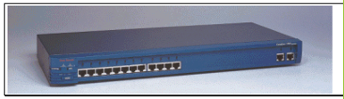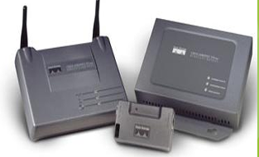

3. Computers: Clients and Servers
In a network, computers play two roles:
- Server: A dedicated computer that provides services (files, printing, email, security) to others. It runs 24/7.
- Client: A computer that requests services from the server. Your laptop is a client.
Real-life example: YouTube's computers are servers. Your phone watching YouTube is the client.

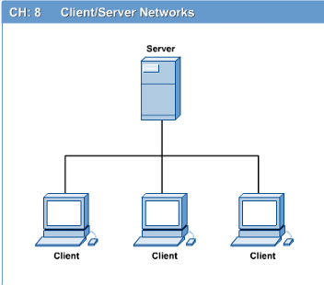

4. Networking Software
Software is needed to control how data is sent and received. This includes protocols (rules for communication) and operating system features.

5. Applications
These are programs that use the network:
- Web browser (Chrome, Firefox)
- Email client (Gmail)
- Video conferencing apps (Zoom, Teams)
- FTP client (for transferring files)

🧠 Memory Trick:
Think of a restaurant: Server = Waiter, Client = Customer, Physical media = Road to deliver food, Router = Traffic police directing cars!

🇧🇩 Bangla Summary:
নেটওয়ার্কের উপাদান হলো: Physical Media (তার/বেতার), Interconnecting Devices (HUB, Switch, Router), Computers (Client ও Server), Networking Software, এবং Applications। সার্ভার সেবা দেয়, ক্লায়েন্ট সেবা নেয়।

Topic 6: Protocol Hierarchies – Layers, Protocols & Interfaces

What is a Protocol?
A protocol is an agreement or a set of rules between two communicating parties about HOW they will communicate.
⭐ Important:
Protocol = Rules of communication. Just like humans follow rules when talking (say 'Hello' first, wait for the other person to reply), computers follow protocols.

What is a Layer?
Networks are organized in layers. Each layer has a specific job. Higher layers use the services of lower layers.
- Think of layers like a company: The CEO (top layer) gives orders to the Manager (middle layer), who gives orders to Workers (bottom layer).
- Each layer communicates with the layer above and below it.
- The same layer on two different computers can communicate through their protocol.

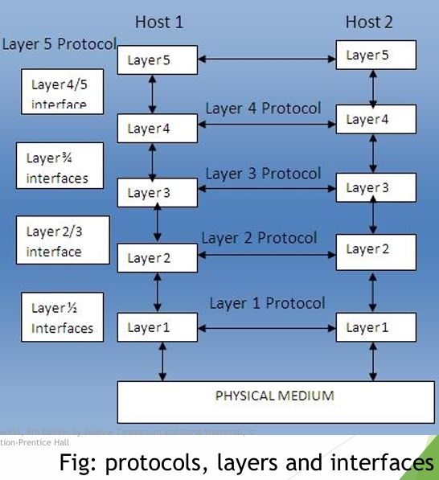

Key Terms
Peers
Peers are entities in the same layer on different machines.
Example: Layer 3 on Computer A communicates logically with Layer 3 on Computer B. They are peers.

Interface
An interface is the boundary between two adjacent layers. It defines what services the lower layer provides to the upper layer.
Example: Layer 2 (Data Link) provides an interface to Layer 3 (Network). Layer 3 doesn't need to know HOW Layer 2 works internally.

Entity
An entity is an active element in a layer. It can be software (a process/program) or hardware (a chip), or both.

Peer Entities
Entities in the same layer on different machines are called peer entities. They use the same protocol to communicate.

Protocol Stack
A protocol stack is a list of protocols used by a system — one protocol for each layer. All the layers together form the protocol stack.
Example: When you browse a website, your computer uses: HTTP (Application) → TCP (Transport) → IP (Network) → Ethernet (Data Link) → Physical cable. This is a protocol stack!

Connections & Multiplexing
Connection-Oriented Service
- A connection is first established, then used, then released.
- Like a phone call: dial → talk → hang up.
- Example: TCP (Transmission Control Protocol)

Connectionless Service
- No connection is set up beforehand. Data is just sent.
- Like sending a letter by post: just write and send.
- Example: UDP (User Datagram Protocol)

Multiplexing
Multiplexing means combining multiple connections into one.
- Upward Multiplexing: Several layer N connections are multiplexed (combined) into one layer N-1 connection.
- Downward Multiplexing: One layer N connection uses several layer N-1 connections.
Real-life example: Many people talking on one telephone cable at the same time = multiplexing!

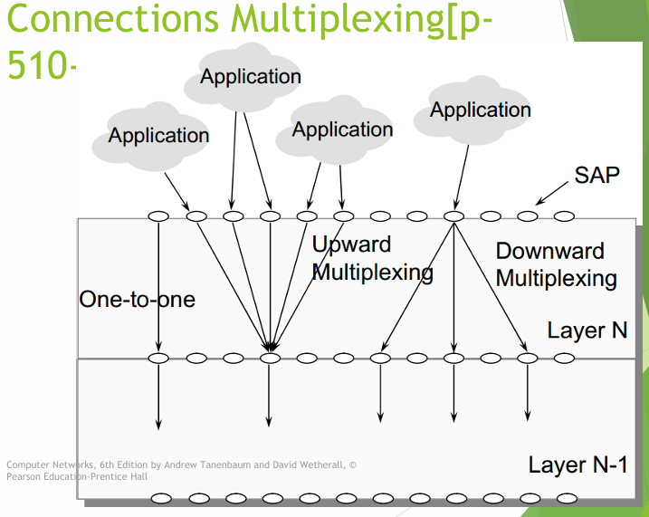

Service Primitives
Service primitives are the commands used by layers to communicate with each other. There are 4 types:

Primitive | Meaning / Direction
REQUEST | Layer N+1 asks Layer N to do something (upper → lower)
INDICATION | Layer N tells Layer N+1 that an event happened (lower → upper)
RESPONSE | Layer N+1 responds to the previous INDICATION (upper → lower)
CONFIRM | Layer N confirms the REQUEST was completed (lower → upper)

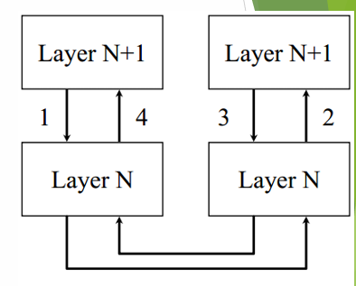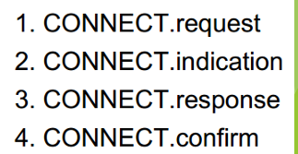

🧠 Memory Trick:
Primitives: R-I-R-C = Request, Indication, Response, Confirm. Like a phone call: I call (Request) → You hear it ring (Indication) → You answer (Response) → Connected (Confirm)!

🇧🇩 Bangla Summary:
Protocol হলো যোগাযোগের নিয়ম। নেটওয়ার্ককে স্তরে স্তরে (Layer) ভাগ করা হয়। প্রতিটি স্তর একটি নির্দিষ্ট কাজ করে। একই স্তরের entities-রা Peers। স্তরের মধ্যে সীমানাকে Interface বলে। Service Primitives হলো স্তরগুলোর মধ্যে যোগাযোগের কমান্ড।

Topic 7: The OSI Reference Model

What is the OSI Model?
OSI stands for Open Systems Interconnection. It was developed by ISO (International Standards Organization).
The OSI model has 7 layers. It is a standard guide for how networks should communicate.
⭐ Important:
OSI Model has 7 layers. Remember from top to bottom: Application, Presentation, Session, Transport, Network, Data Link, Physical.

🧠 Memory Trick:
Memory trick (top to bottom): 'All People Seem To Need Data Processing' → Application, Presentation, Session, Transport, Network, Data Link, Physical

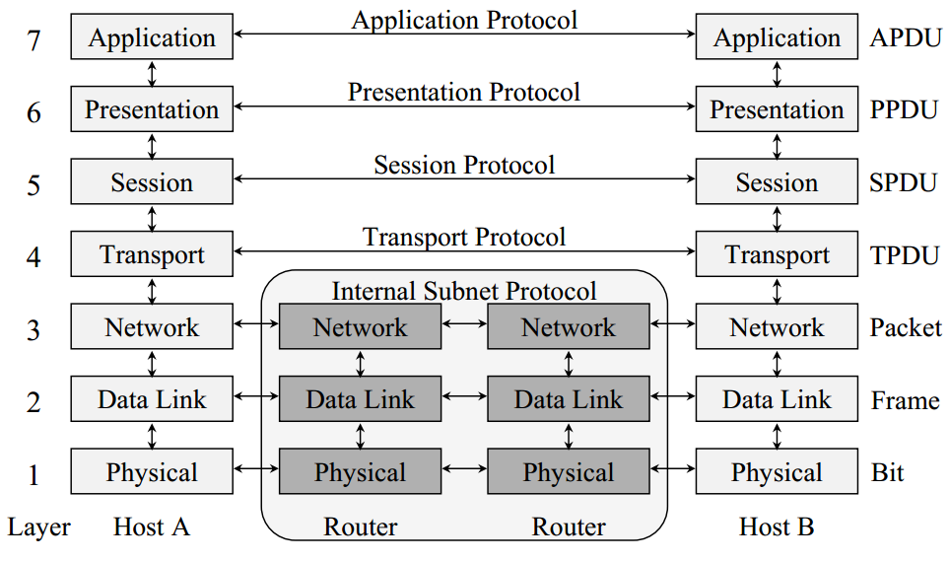

Layer 7 – Application Layer
This is the top layer. It is the layer closest to the user.
- Makes sure the other party is identified and can be reached.
- Authenticates the sender or receiver.
- Checks that necessary resources exist (like a modem or internet connection).
- Ensures agreement about error recovery, data integrity, and privacy.
- Sets the protocol and data syntax rules at the application level.
Real-life example: When you open Gmail in Chrome, the browser uses Application Layer protocols (HTTP, SMTP) to communicate.

Layer 6 – Presentation Layer
This layer handles how data is represented (formatted).
- Translates different data formats between computers.
- Example: Converts ASCII text to the network standard format.
- Handles data encryption and compression.
Real-life example: When you send a photo, it may be compressed (made smaller) by the Presentation Layer so it travels faster.
Think of it as a translator: It makes sure both computers understand each other's data format.

Layer 5 – Session Layer
This layer manages sessions (conversations) between computers.
- Sets up, coordinates, and ends conversations between applications.
- Controls the exchange of information.
- Provides synchronization (makes sure both sides are in sync).
Real-life example: When you log into a website, a session is created. When you log out, the session is terminated.

Layer 4 – Transport Layer
This layer ensures reliable data delivery from end to end.
- Accepts data from the Session Layer and splits it into smaller units (segments).
- Passes the segments to the Network Layer.
- Makes sure ALL pieces arrive correctly at the destination.
- Checks the sequence of packets (orders them correctly).
Real-life example: Like a courier service that tracks every parcel and makes sure all parts of a large shipment arrive and are in the right order.
Protocols: TCP (reliable), UDP (fast but unreliable)

Layer 3 – Network Layer
This layer handles routing – finding the best path for data from source to destination.
- Performs network routing (finding the path).
- Handles flow control and error control.
- Prevents network congestion (too much data clogging the network).
Real-life example: Like a GPS system for data. It finds the best route for your data from Dhaka to London.
Protocol: IP (Internet Protocol)

Layer 2 – Data Link Layer
This layer provides reliable transfer of data between directly connected nodes.
- Takes the bit stream from the Network Layer and breaks it into frames.
- Passes frames to the Physical Layer for transmission.
- At the receiving end, detects and possibly corrects errors.
- Passes the correct stream back to the Network Layer.
- Also handles flow control.
Real-life example: Like a delivery man who packages letters (frames), delivers them, and makes sure none are lost on the way.
Protocols: HDLC, Ethernet, PPP

Layer 1 – Physical Layer
This is the bottom layer. It deals with the actual bits being transmitted.
- Transmits raw bits over a communication channel (cable, fiber, wireless).
- Establishes and terminates a physical connection.
- Ensures that when one side sends '1', the other side receives '1' (not '0').
Real-life example: The actual cable, Wi-Fi signal, or fiber optic light pulses that carry the data.

Layer নং | Layer নাম | প্রধান কাজ | Protocol/Device | Data Unit
7 | Application | User Interface, Network Services | HTTP, FTP, SMTP, DNS | Data/Message
6 | Presentation | Translation, Encryption, Compression | JPEG, SSL, TLS | Data
5 | Session | Session Management | NetBIOS, PPTP | Data
4 | Transport | End-to-End Delivery, Flow/Error Control | TCP, UDP | Segment
3 | Network | Routing, Logical Addressing | IP, ICMP, Router | Packet
2 | Data Link | Framing, MAC Addressing, Error Detection | Ethernet, Switch | Frame
1 | Physical | Bit Transmission, Physical Medium | Hub, Cable, NIC | Bit

Layer | Name
7 | Application Layer – User interaction, HTTP, SMTP, FTP
6 | Presentation Layer – Data format, encryption, compression
5 | Session Layer – Manage sessions, synchronization
4 | Transport Layer – Reliable delivery, TCP/UDP, sequencing
3 | Network Layer – Routing, IP addressing, congestion control
2 | Data Link Layer – Frames, error detection, flow control
1 | Physical Layer – Bits, cables, signals, hardware

🧠 Memory Trick:
Bottom-up memory trick: 'Please Do Not Throw Sausage Pizza Away' → Physical, Data Link, Network, Transport, Session, Presentation, Application

🇧🇩 Bangla Summary:
OSI Model এ ৭টি স্তর আছে। নিচ থেকে উপরে: Physical (তার/সংকেত), Data Link (ফ্রেম তৈরি), Network (রাউটিং), Transport (নির্ভরযোগ্য ডেলিভারি), Session (সেশন পরিচালনা), Presentation (ফরম্যাট ও এনক্রিপশন), Application (ব্যবহারকারীর সাথে ইন্টারফেস)।

Topic 8: The TCP/IP Reference Model

What is TCP/IP?
TCP/IP stands for Transmission Control Protocol / Internet Protocol. It is the actual model used by the Internet.
Unlike OSI (which has 7 layers), TCP/IP has 4 layers:

TCP/IP Layer | Equivalent OSI Layers
Application | Application + Presentation + Session (OSI 7, 6, 5)
Transport | Transport (OSI 4)
Internet | Network (OSI 3)
Network Access / Link | Data Link + Physical (OSI 2, 1)

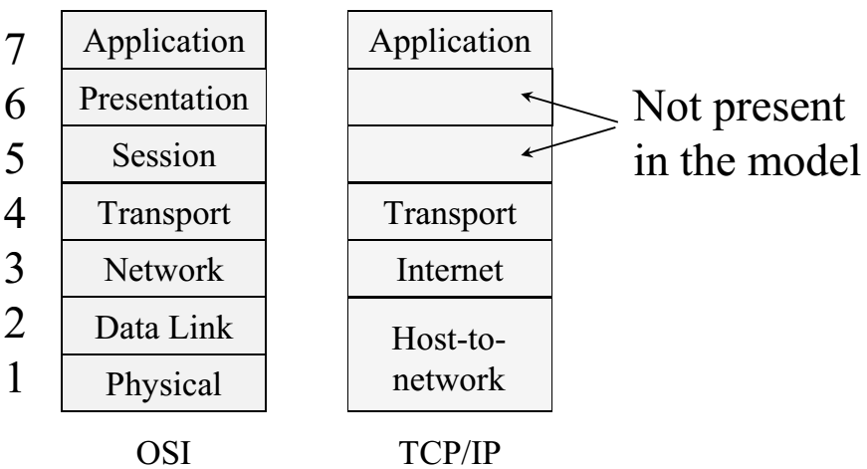

Key Difference: OSI vs TCP/IP
- OSI: 7 layers – theoretical model, good for learning.
- TCP/IP: 4 layers – practical model, actually used on the Internet.
- OSI separates Presentation and Session layers. TCP/IP combines them into Application.

🧠 Memory Trick:
TCP/IP = 4 layers: Application, Transport, Internet, Network Access. Remember: A-T-I-N = 'A Tiny Internet Network'

🇧🇩 Bangla Summary:
TCP/IP হলো ইন্টারনেটে ব্যবহৃত আসল মডেল। এতে ৪টি স্তর আছে: Application, Transport, Internet, এবং Network Access। OSI মডেল শেখার জন্য, আর TCP/IP বাস্তবে ব্যবহারের জন্য।

Topic 9: Data Link Control – HDLC

What is HDLC?
HDLC stands for High-Level Data Link Control. It is a protocol used at the Data Link Layer.
HDLC defines HOW data is packaged into frames and sent reliably between two nodes.

HDLC Frame Structure
Every HDLC frame has this structure:

Frame Part | Description
Flag (01111110) | Marks the beginning and end of every frame. It is a special bit pattern.
Address Field | Identifies which terminal the frame is for (on lines with multiple terminals).
Control Field | Contains sequence numbers, acknowledgements, and control info.
Data Field | The actual information being sent. Can be any length.
CRC (Checksum) | Error checking field using Cyclic Redundancy Code technique.
End Flag (01111110) | Same as the start flag – marks end of frame.

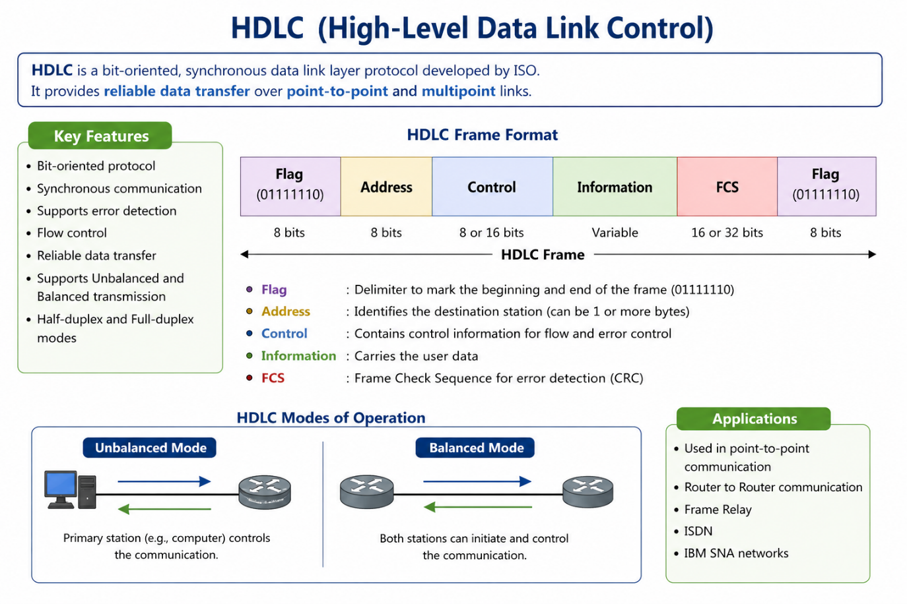

⭐ Important:
Flag = 01111110. If this bit pattern appears inside the data, byte stuffing is used to avoid confusion. A '0' bit is inserted after every 5 consecutive '1' bits.

Three Types of HDLC Frames
1. Information Frame (I-Frame)
Used to send actual data.
- SEQ (3 bits): Sequence number of the frame being sent.
- NEXT: Piggybacked acknowledgement – contains the number of the next expected frame.
- P/F bit: Poll/Final bit. P = Polling (asking terminals to send). F = Final frame from terminal.
Uses sliding window protocol. Up to 7 unacknowledged frames can be in transit at the same time (3-bit sequence number → 0 to 7).

2. Supervisory Frame (S-Frame)
Used for control purposes – no user data. There are 4 types:
- Type 00 – RECEIVE READY (RR): I'm ready. The next frame I expect is NEXT.
- Type 01 – REJECT (REJ): Error! Resend all frames starting from NEXT.
- Type 10 – RECEIVE NOT READY (RNR): Stop sending! I am busy. (Also acknowledges frames up to NEXT-1).
- Type 11 – SELECTIVE REJECT (SREJ): Error in one specific frame. Resend only that frame.

3. Unnumbered Frame (U-Frame)
Used for control and for connectionless data transfer.
- DISC (Disconnect): Tell the other side to close the connection.
- SABM (Set Asynchronous Balanced Mode): Reset the line.
- FRMR (Frame Reject): Received a frame with correct checksum but wrong meaning (semantic error).

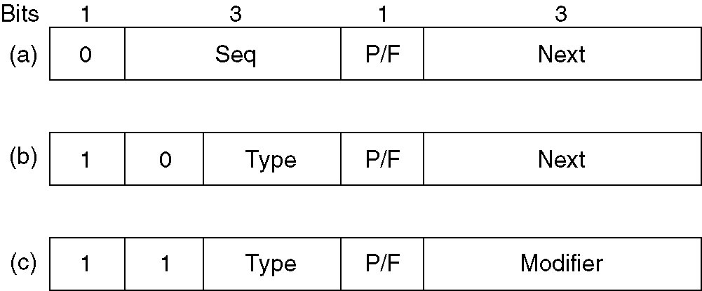

Frame Type | Purpose
Information (I-Frame) | Send actual data with sequence numbers and acknowledgements.
Supervisory (S-Frame) | Control: Ready, Reject, Not Ready, Selective Reject.
Unnumbered (U-Frame) | Control: Connect, Disconnect, Reset, Error reporting.

🧠 Memory Trick:
HDLC Frame = Flag | Address | Control | Data | CRC | Flag. Remember: 'Friendly ACDs Cheerfully Farewell!' (Flag, Address, Control, Data, CRC, Flag)

🇧🇩 Bangla Summary:
HDLC হলো Data Link Layer এর একটি প্রোটোকল। এটি ডেটাকে ফ্রেমে ভাগ করে পাঠায়। প্রতিটি ফ্রেমে থাকে: Flag, Address, Control, Data, CRC, এবং Flag। তিন ধরনের ফ্রেম: Information (ডেটা পাঠানো), Supervisory (নিয়ন্ত্রণ), Unnumbered (সংযোগ ব্যবস্থাপনা)।

📝 EXAM REVISION NOTES
Quick key points for exam preparation:

Computer Network Basics
- Network = 2+ autonomous computers connected to share resources.
- LAN = Local (room/building). MAN = City. WAN = Country/World.
- Internet = Biggest WAN.

Network Topology (BSRM)
- Bus: One cable, all devices connected to it. Single point of failure.
- Star: Central hub/switch. Most common. Hub failure = all fail.
- Ring: Circle. Single ring (one way) or Dual ring (two ways).
- Mesh: All-to-all. Most reliable. Most expensive. Used in WANs/banks.

Protocol, Layers & Interfaces
- Protocol = rules for communication between two parties.
- Peer = same layer on different machines.
- Interface = boundary between adjacent layers.
- Protocol Stack = one protocol per layer, all layers together.
- Service Primitives: Request → Indication → Response → Confirm.

OSI Model – 7 Layers (top to bottom)
- 7. Application – User interface (HTTP, SMTP, FTP).
- 6. Presentation – Format, encryption, compression.
- 5. Session – Manage sessions.
- 4. Transport – Reliable delivery, TCP, UDP.
- 3. Network – Routing, IP.
- 2. Data Link – Frames, error detection (HDLC, Ethernet).
- 1. Physical – Bits, cables, signals.

TCP/IP Model – 4 Layers
- Application (= OSI 7+6+5).
- Transport (= OSI 4).
- Internet (= OSI 3).
- Network Access (= OSI 2+1).

HDLC
- Frame = Flag | Address | Control | Data | CRC | Flag.
- Flag = 01111110.
- 3 frame types: I-Frame (data), S-Frame (control), U-Frame (unnumbered/control).
- S-Frame types: RR (ready), REJ (reject/resend all), RNR (not ready), SREJ (selective reject).
- Sliding window: 3-bit SEQ → up to 7 unacknowledged frames in transit.

⭐ Important:
Memory Tricks: • Topologies: B-S-R-M = 'Be Smart, Ring Mesh' • OSI (top→bottom): 'All People Seem To Need Data Processing' • OSI (bottom→up): 'Please Do Not Throw Sausage Pizza Away' • TCP/IP: A-T-I-N = 'A Tiny Internet Network' • HDLC Frame: 'Friendly ACDs Cheerfully Farewell' = Flag, Address, Control, Data, CRC, Flag

— End of Week 1 Notes —
Shaon Khan
IIT-14 JU-52
01633040670

